Thur. | Term One | Yr. 10 Hass.
Learning Intention: Assessment paper

Activities:
- Read through the task with the students
- Allow writing time.

Success Criteria: Able …..

Yr.10 HASS
LEARNING INTENTIONS:

To ……

Yr.10 HASS
SUCCESS CRITERIA:

Able …..

Thur. | Term One | Yr. 8 HASS
Learning Intention: To understand the requirements of the inquiry task.

To begin recording information relating to life in the Medieval period

Activities:
- Daily riddle
- https://www.youtube.com/watch?v=pI5_idvxm18 (9.31) ) Part Three Extra History, the First Crusade
- Ask students to take out their ‘Everyday Life’ graphic organiser and ‘Main Religions’ Venn diagram students compare and contrast with a partner
- https://www.youtube.com/watch?v=UdzsMEHUBrQ (10.15) Part Four Extra History, the First Crusade.
Success Criteria: Understand the requirements of the inquiry task and have successfully begun to record essential information related to life within the medieval period.

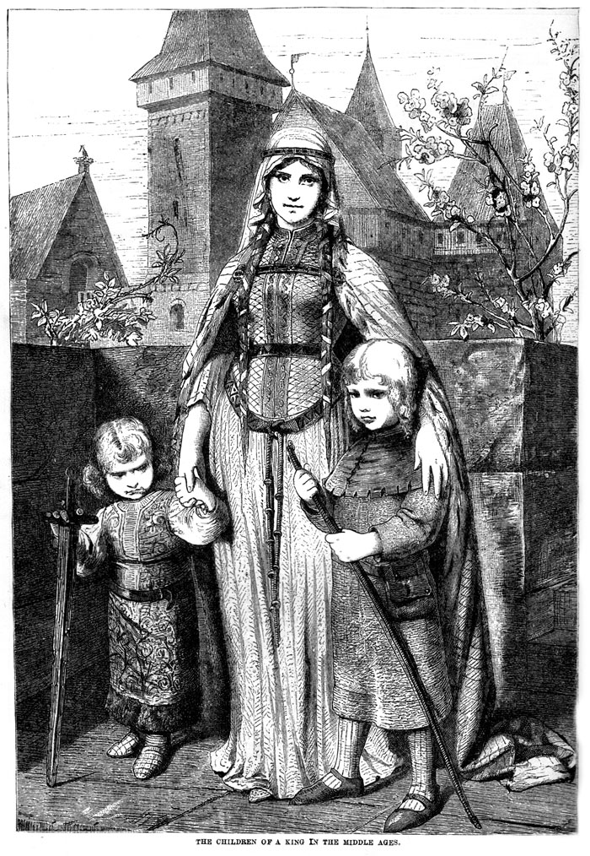

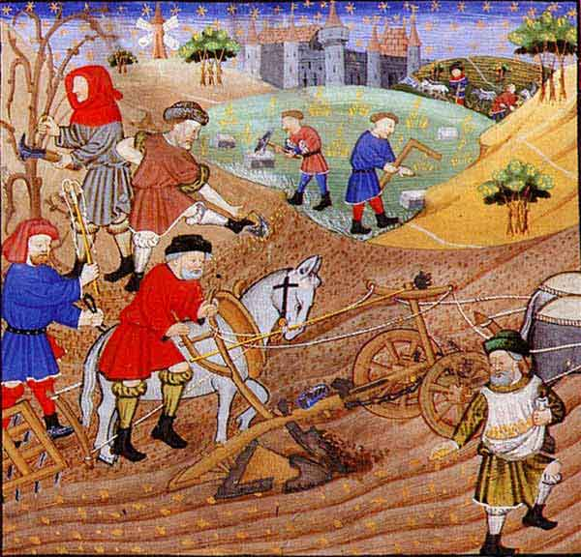



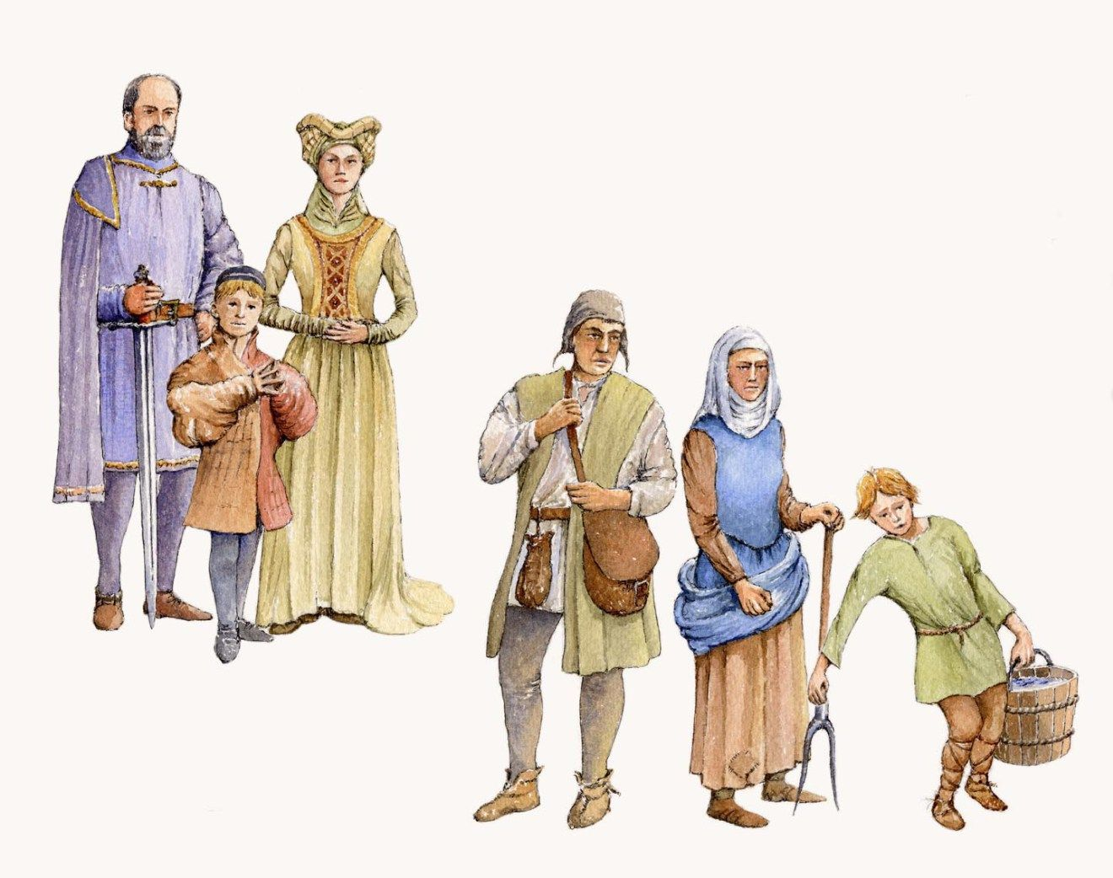

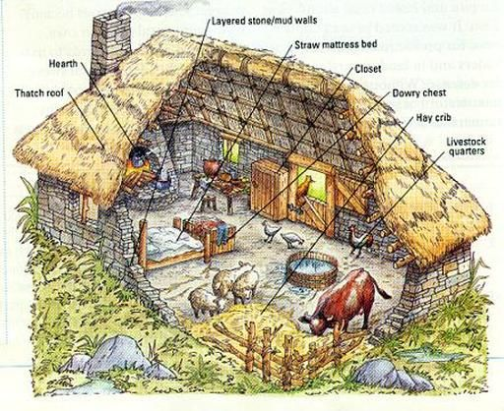
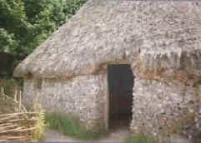

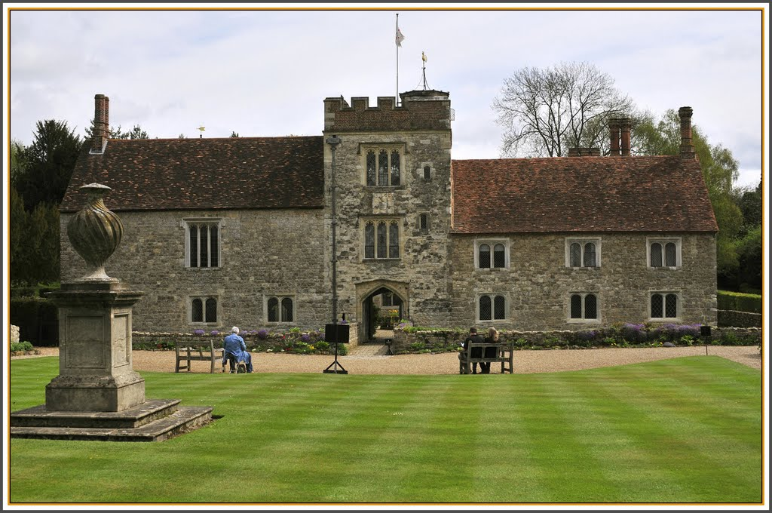

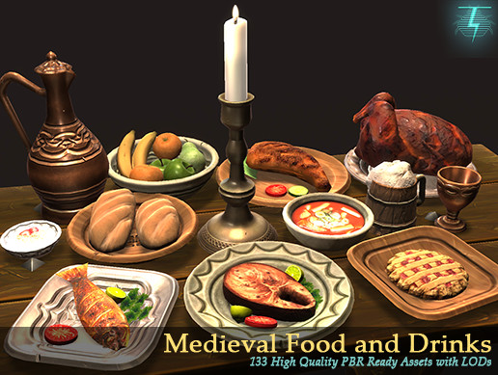


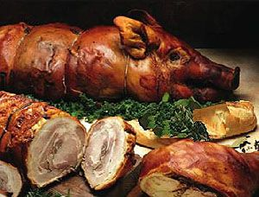

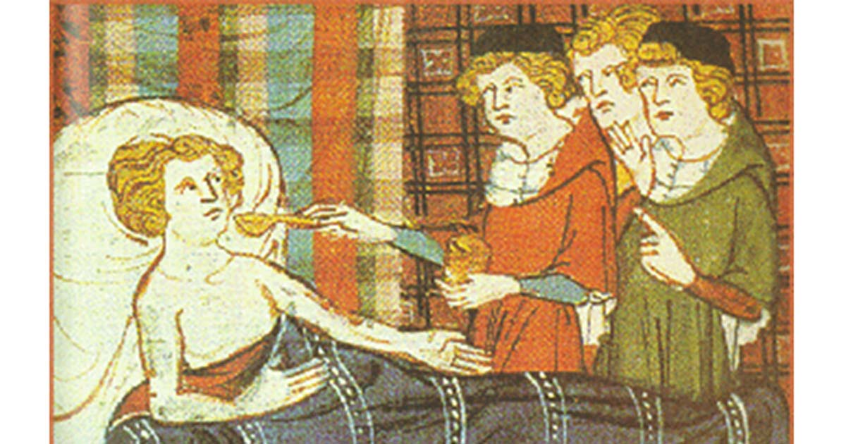

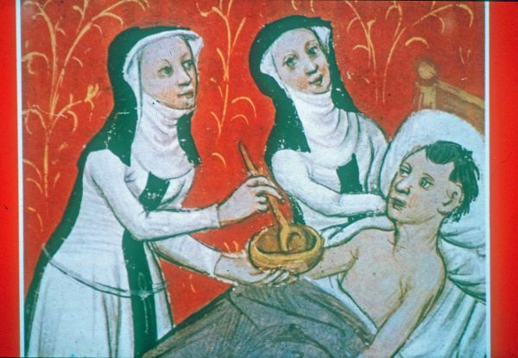

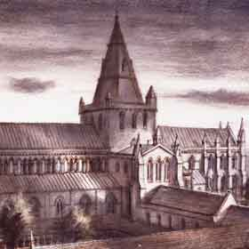




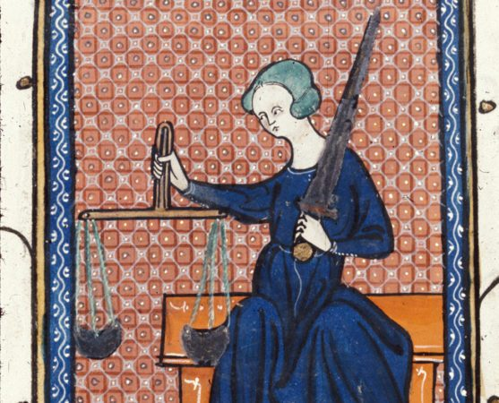
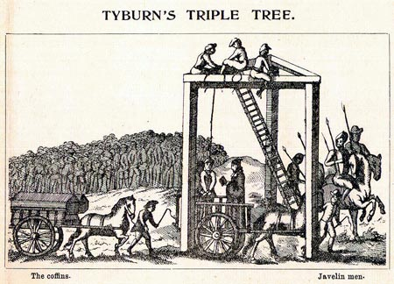

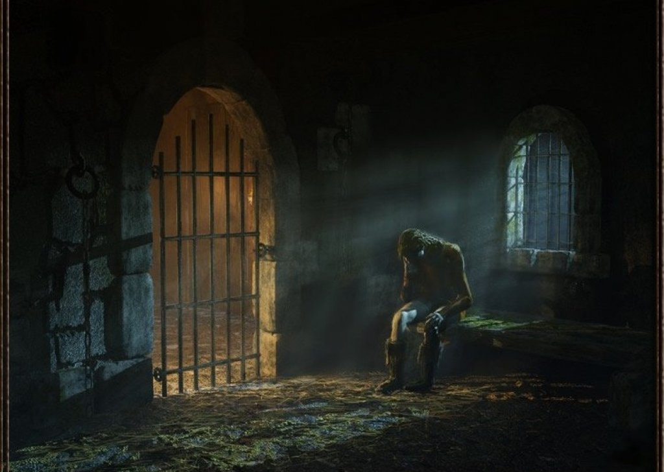
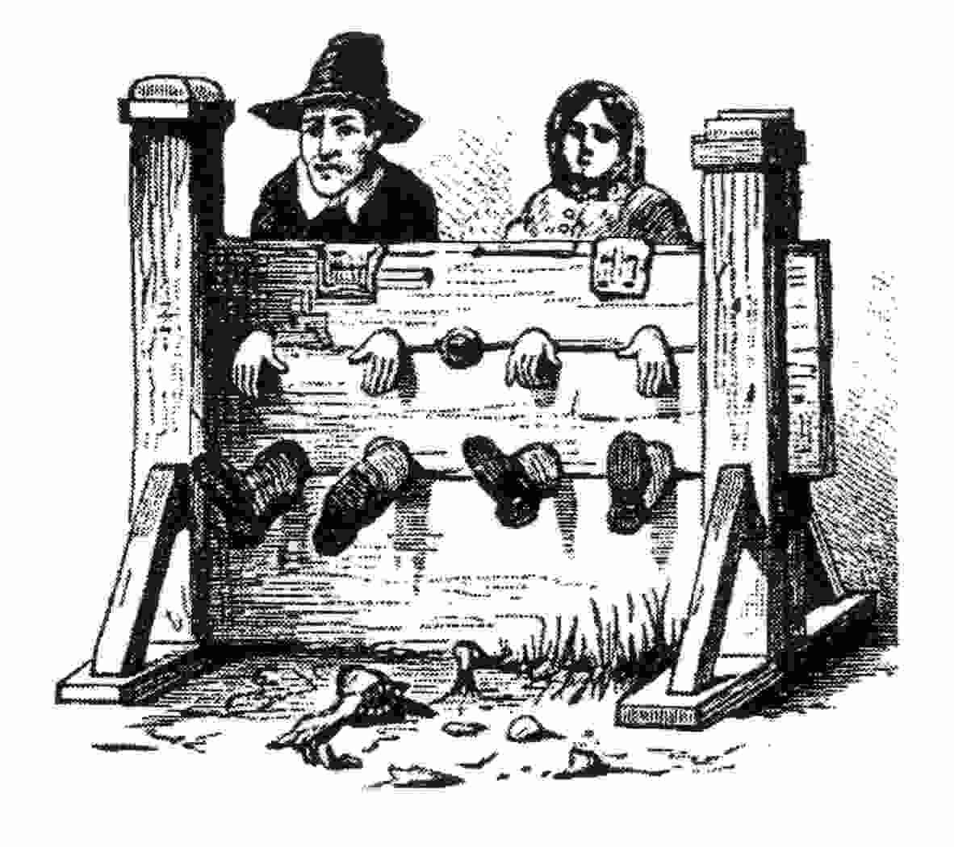

Yr.8 HASS
LEARNING INTENTIONS:

To understand the requirements of the inquiry task.

To begin recording information relating to life in the Medieval period

Yr.8 HASS
SUCCESS CRITERIA:

Understand the requirements of the inquiry task and have successfully begun to record essential information related to life within the medieval period.

Thur. | Term One | Yr. 12 Modern History
Learning Intention: To …..

Activities:
- Go through the source analysis practice paper from yesterday
- Formal assessment source analysis paper

Success Criteria: Able …..

Yr.12 Modern History
LEARNING INTENTIONS:

To …..

Yr.12 Modern History
SUCCESS CRITERIA:

Able …..

